Chris Matich

Sarah Leavens

Professional Uses of Social Media

23 January 2018

Story - Shaquille O’Neal

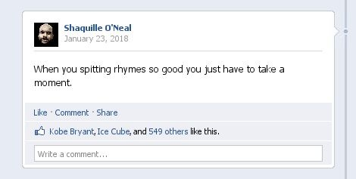
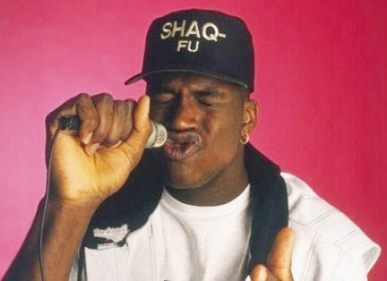
Post 1: (The FB emulator I used wouldn’t let you add images to the post, the images that accompany posts will be shown below them)

Post 1 Explanation: For my story, I wanted to resurrect Shaq’s rapping career with a series of posts. This first one is just sort of like an expositional post. It lets the viewer know that Shaq does, indeed, rap.

Post 2:
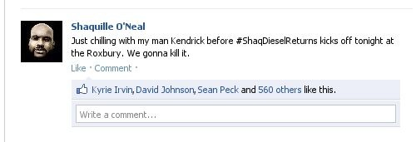
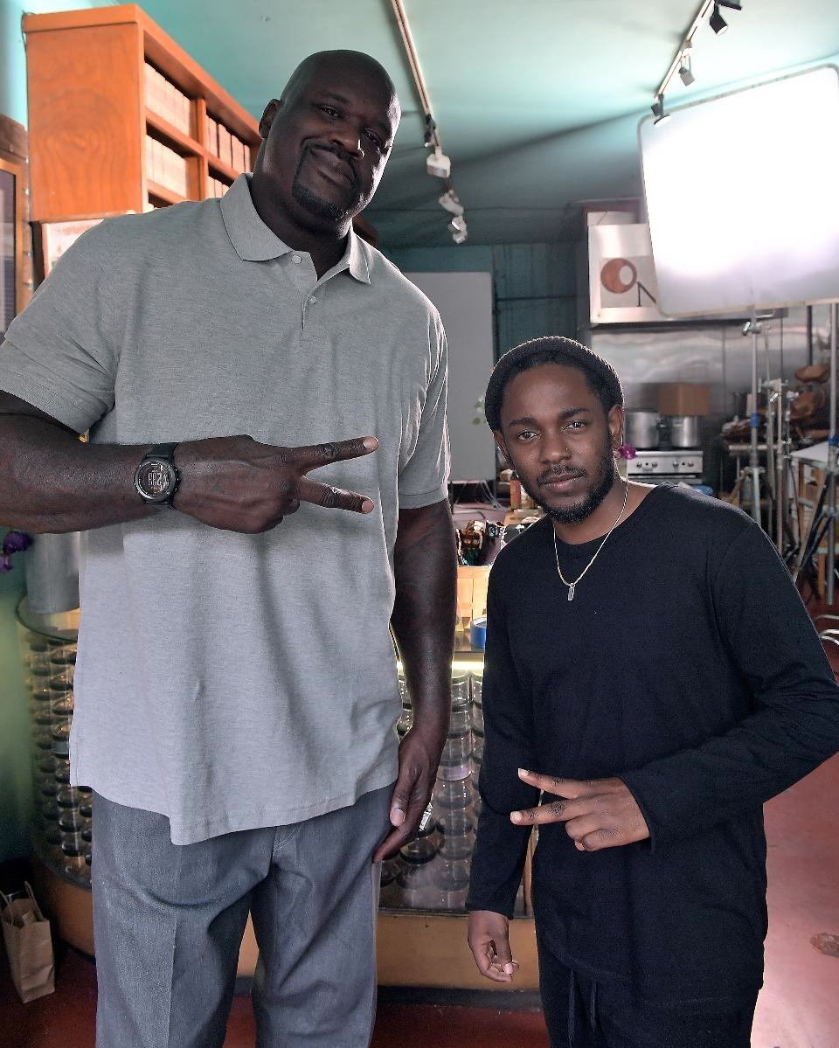

Post 2 Explanation:

Here we see Shaq posting a picture of him with the very famous, ubiquitously praised hip hop artist, Kendrick Lamar. Shaq shares this picture to show you the type of people you can expect him to associate with as he attempts to relaunch his hip hop career, he wants you to know he is with the best artists of the time. Moreover, this post includes the first use of his hashtag, #ShaqDieselReturns, which tells the artist first that he is attempting a musical comeback (his first album was called Shaq Diesel) and that he is holding a show that day.

Post 3:
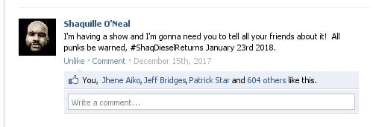
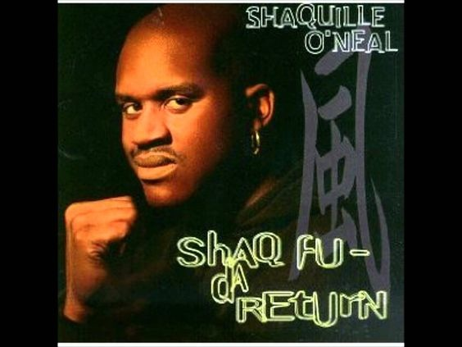
Post 3 Explanation:

This post occurred before the previous two, by about a month. This is the post that Shaq had to make to announce his intentions to return to performing music. Each week leading up to the event Shaq could make a similar post counting down to his show, leading us to Post 4 on the date of the show.

Post 4:
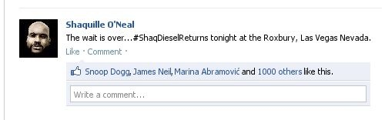
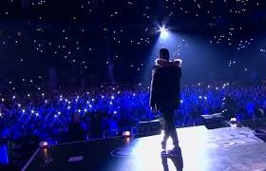

Post 4 Explanation:

Here we see an image of Shaq performing onstage paired with his announcement that his countdown toward the show is over. It gives the reader an idea of what will happen, obviously a performance of some kind, and where.

Post 5:
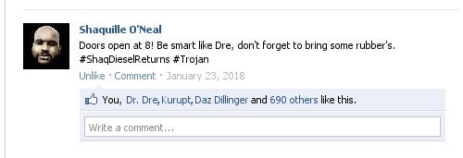
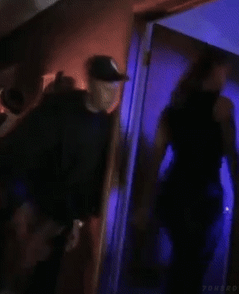

Post 5 Explanation:
This is another post Shaq makes during the build up to the concert on the day of that creates buzz and makes people talk about the show. This gif image is from a concert Dre once made and recorded for a made for DVD movie, Up In Smoke, and the trope of Dre holding condoms is a common image related large, publicized concerts with multiple artists, the idea being that the artists will need the condoms following the concert when they meet up with groupies. I also thought maybe it could lead to a little sponsorship here, by trojan.

Post 6:

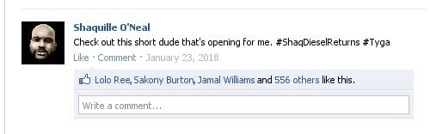
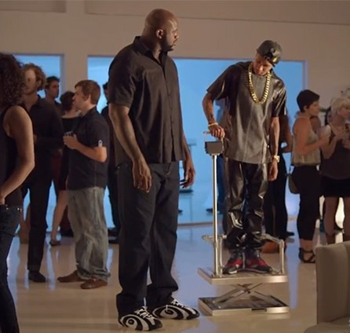
Post 6 Explanation: This post comes an hour or so before the concert begins, so it makes sense that Shaq is outlining who will be performing. Being freakishly tall is a huge part of Shaq’s brand, not just as a musician or rapper, but as a person.

Post 7:
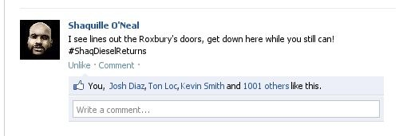

Post 7 Explanation:

This is the last post Shaq makes before going live at his concert.

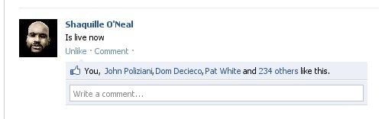
Post 8:

Post 8 Explanation:

This is the last post Shaq makes before the end of the concert, and this way, the viewers can see what is going on exactly at that moment of the concert.

Post 9:
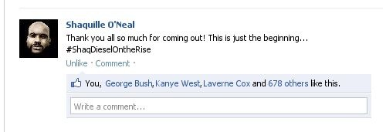

Post 9 Explanation:

This post is meant to wrap up the story, at least in terms of the concert, by letting fans know that this isn’t the only event Shaq will be holding. I wanted to include a post about upcoming tour dates, but I assume that he wouldn’t have them all lined up the night after his first concert.

